NORTHAMPTON PROSTATE CANCER SUPPORT GROUP

AGM FOR THE PERIOD:
01 OCT 2021 TO 07 SEPT 2022

AGENDA

- Welcome

- Apologies

- Minutes from last AGM

- Chairman’s Report

- Treasurers Report

- Questions from the members

- AOB


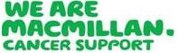
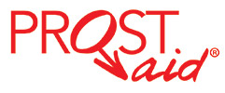
Affiliated to:

